**PROJECT PHASE-4**

**TITLE:WEBSITE TRAFFIC ANALYSIS.**

Here is how you can continue building your analysis by creating visualizations using IBM Cognos and integrating Python code for advanced analysis:

Step 1: Create a data module in IBM Cognos

A data module in IBM Cognos is a logical representation of a data source. It provides a way to organize and manage your data in a way that is easy to use for reporting and analysis.

To create a data module, you will need to connect to your data source and define the dimensions and measures that you want to include. Once you have created the data module, you can publish it to IBM Cognos so that it can be used in dashboards and reports.

Step 2: Create a dashboard in IBM Cognos

A dashboard in IBM Cognos is a visual representation of data that provides you with insights into your business. You can create dashboards to track key performance indicators (KPIs), monitor trends, and identify opportunities.

To create a dashboard, you will need to add visualizations to the dashboard canvas. You can add visualizations from the IBM Cognos library or create your own custom visualizations using Python.

Step 3: Integrate Python code into your IBM Cognos dashboard

You can integrate Python code into your IBM Cognos dashboard to create custom visualizations and perform more complex analyses on your data. To do this, you will need to use the IBM Cognos Analytics Python API.

The IBM Cognos Analytics Python API provides a set of Python functions that you can use to interact with IBM Cognos Analytics. You can use the API to read and write data, create and modify visualizations, and schedule reports.

Step 4: Deploy your dashboard to IBM Cognos

Once you have created your dashboard, you can deploy it to IBM Cognos so that other users can view it. To do this, you will need to publish the dashboard to a Cognos content store.

Step 5: Use your dashboard to gain insights

Once your dashboard is deployed, you can use it to gain insights into your data. You can explore the different visualizations and interact with the dashboard to get a deeper understanding of your data.

**Here are some examples of how you can use IBM Cognos and Python to perform advanced analysis on your website traffic data:**

* Time series analysis

You can use Python to perform time series analysis on your website traffic data to identify trends and seasonality. For example, you can use Python to create a line chart that shows the total number of visitors to your website over time. You can also use Python to calculate the average number of visitors to your website per day, week, or month.

* User segmentation

You can use Python to segment your users based on their behavior and demographics. For example, you can segment your users based on the pages they visit, the sources they come from, and the devices they use. You can also segment your users based on their age, gender, location, and interests.

Once you have segmented your users, you can use IBM Cognos to create dashboards and reports that show how each segment is interacting with your website. For example, you can create a dashboard that shows the top pages visited by each segment, the average time spent on each page, and the bounce rate for each page.

* Machine learning-based predictions

You can use machine learning to predict future website traffic trends and user behavior. For example, you can train a machine learning model to predict the number of visitors to your website on a given day based on historical data, such as the day of the week, the time of year, and the weather forecast.

You can also use machine learning to predict which users are most likely to churn. This information can be used to target these users with retention campaigns.

**MACHINE LEARNING MODELS:**

To use machine learning to predict future website traffic trends and user behavior using IBM Cognos and Python, you can follow these steps:

1. Prepare your data

The first step is to prepare your website traffic data for machine learning. This involves cleaning the data, removing any outliers, and encoding categorical variables. You can use Python to do this.

2. Choose a machine learning algorithm

There are many different machine learning algorithms that you can use to predict website traffic. Some popular algorithms include:

* Linear regression
* Logistic regression
* Support vector machines
* Decision trees
* Random forests
* Neural networks

You can choose an algorithm based on the specific problem that you are trying to solve. For example, if you are trying to predict the total number of visitors to your website on a given day, you could use a linear regression algorithm. If you are trying to predict whether a user is likely to churn, you could use a logistic regression algorithm.

3. Train the machine learning model

Once you have chosen a machine learning algorithm, you need to train the model on your website traffic data. You can use Python to do this.

4. Evaluate the machine learning model

Once the machine learning model is trained, you need to evaluate its performance on a held-out test set. This will give you an idea of how well the model will perform on new data.

5. Deploy the machine learning model

Once you are satisfied with the performance of the machine learning model, you can deploy it to production. You can use IBM Cognos to do this**.**

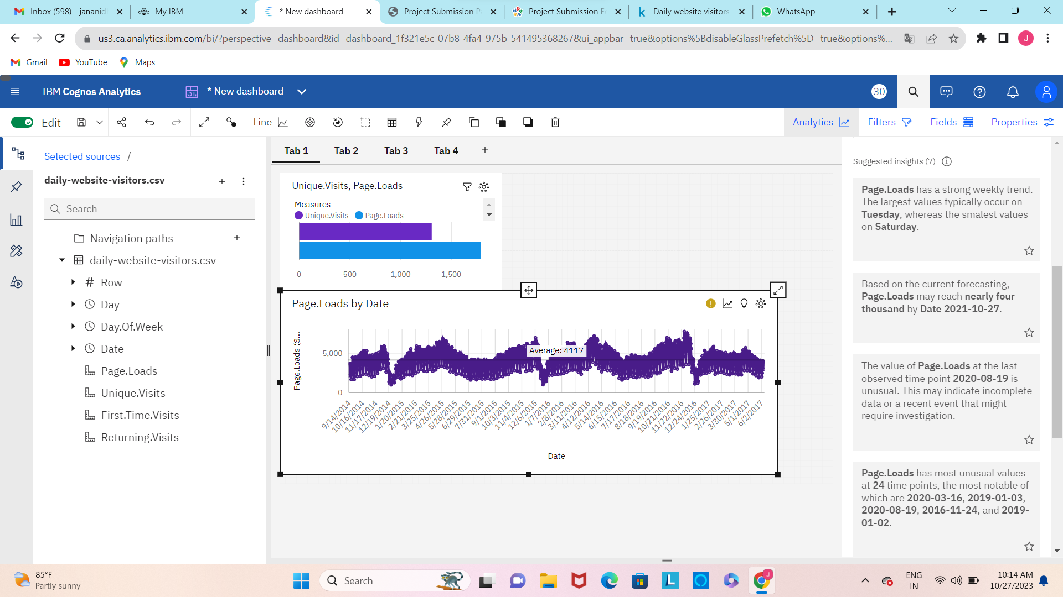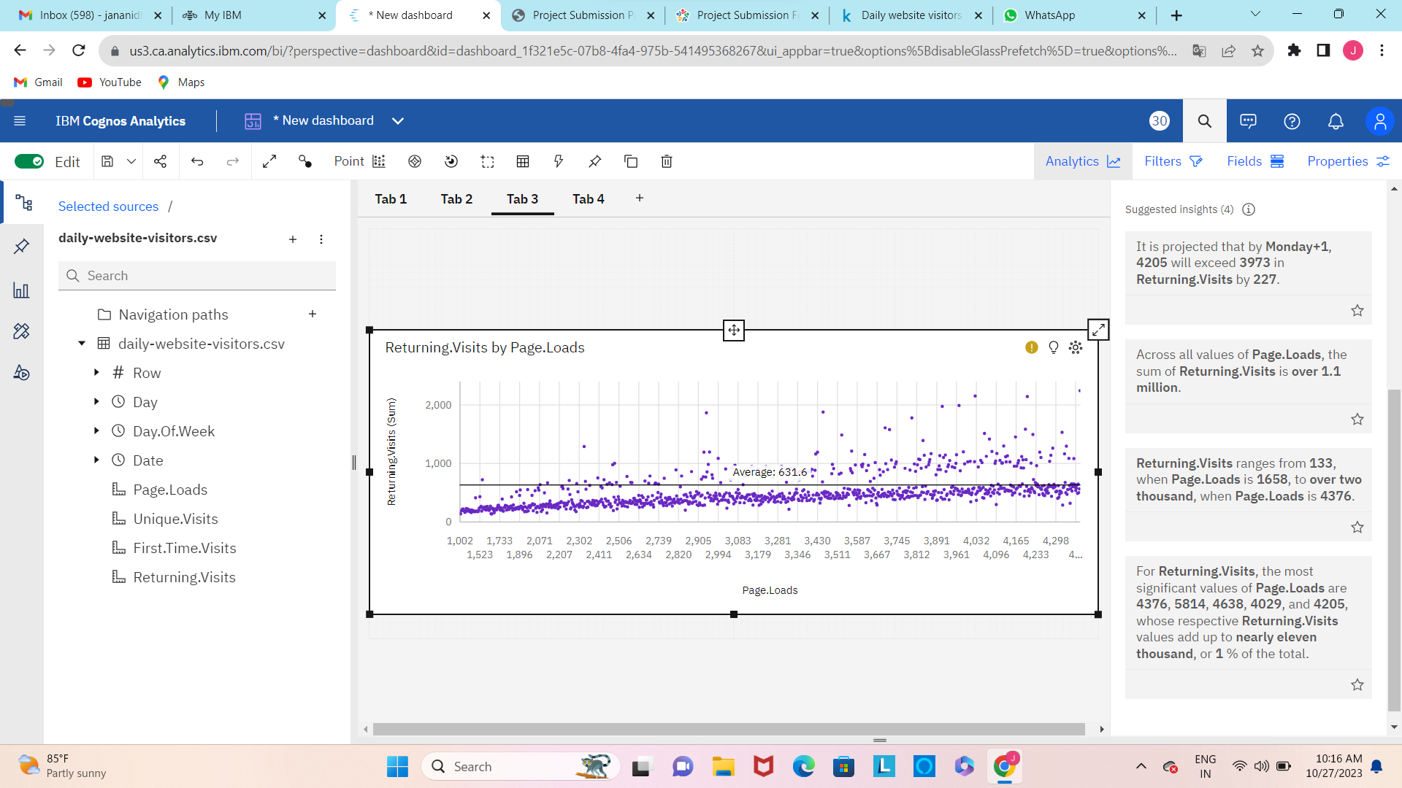**VISUALIZATION USING IBM COGNOS**

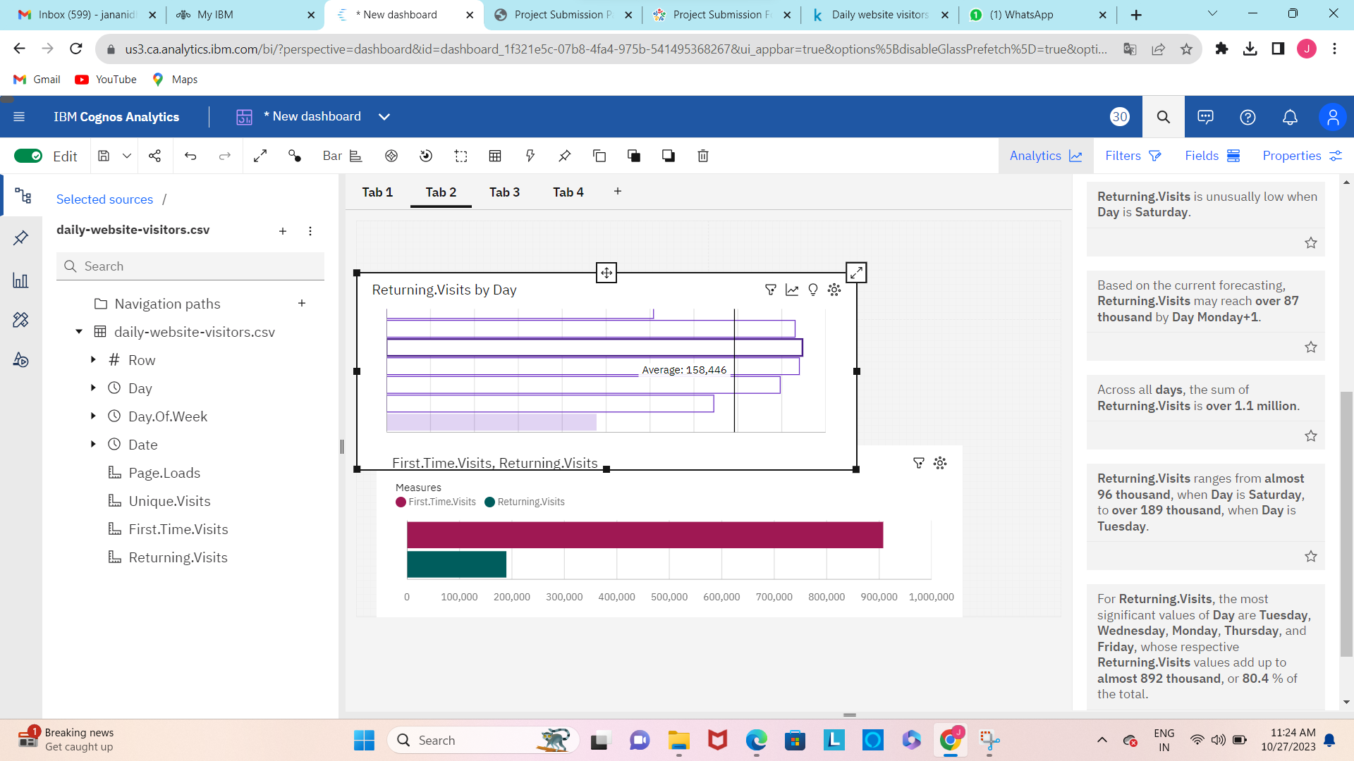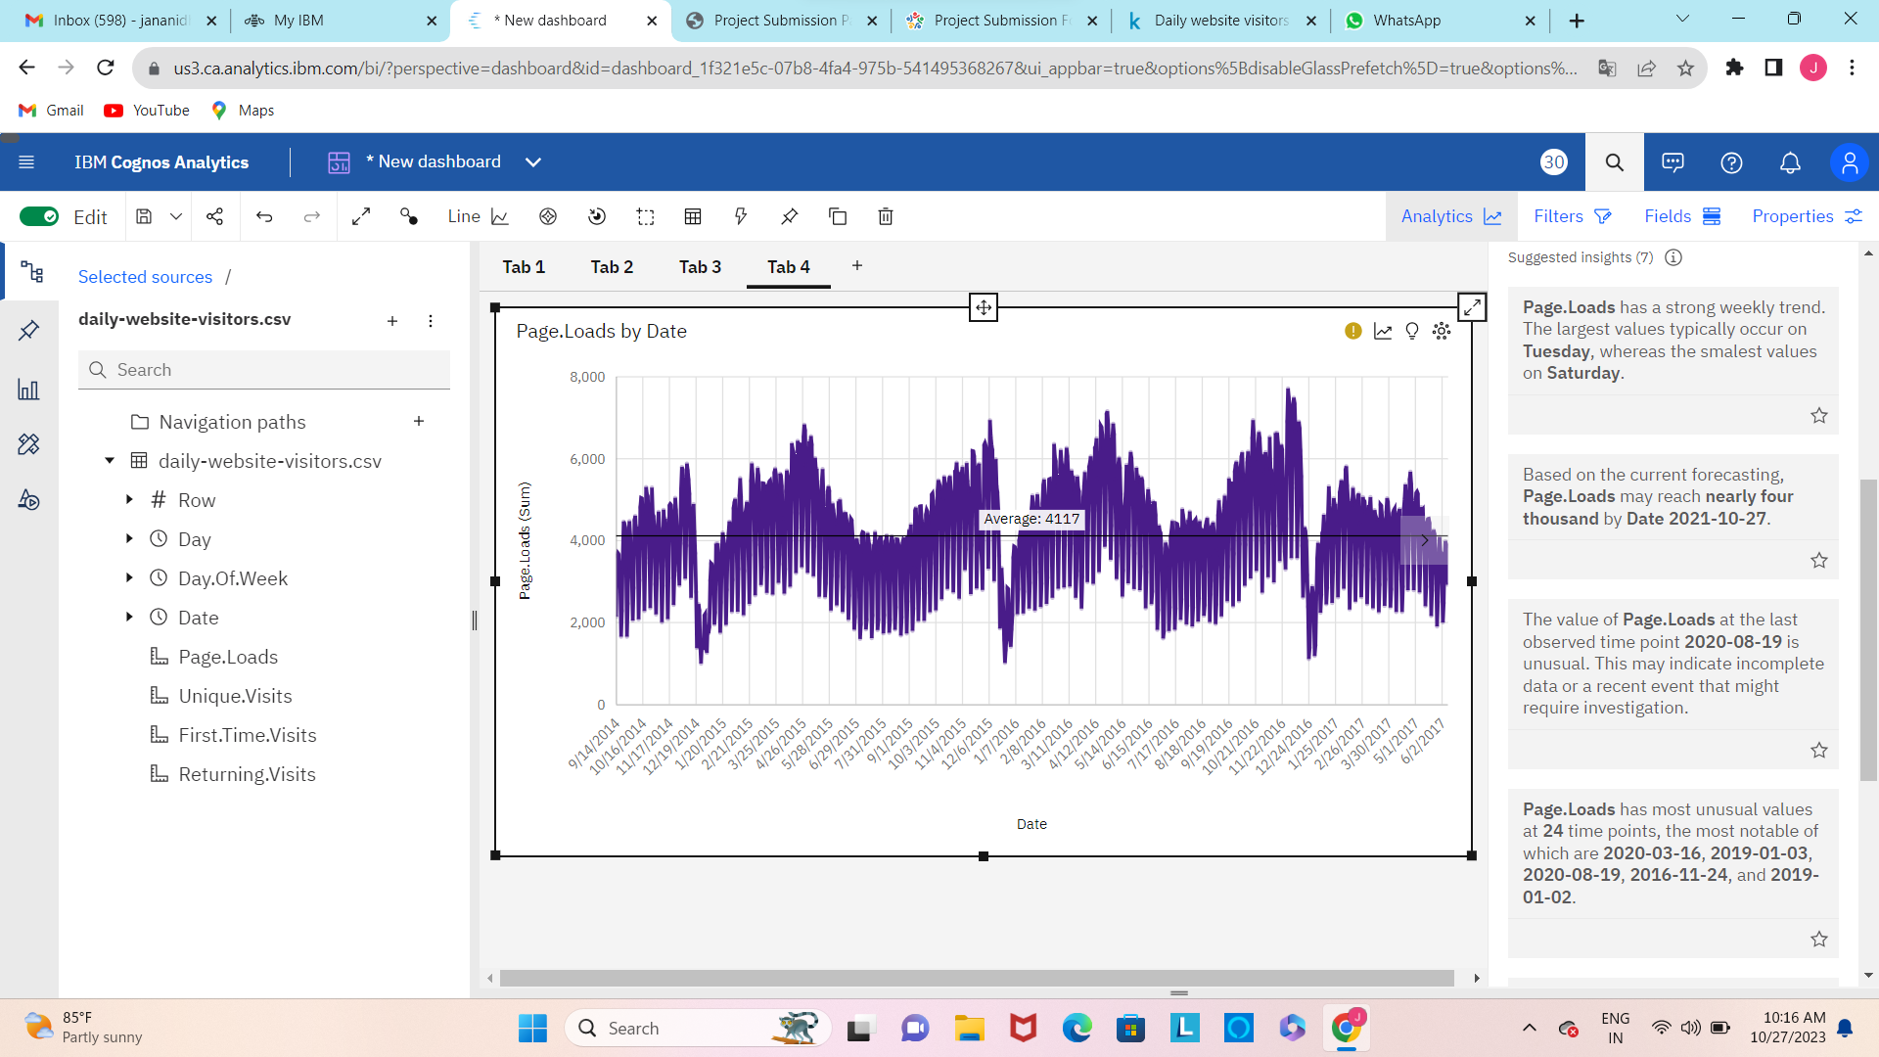

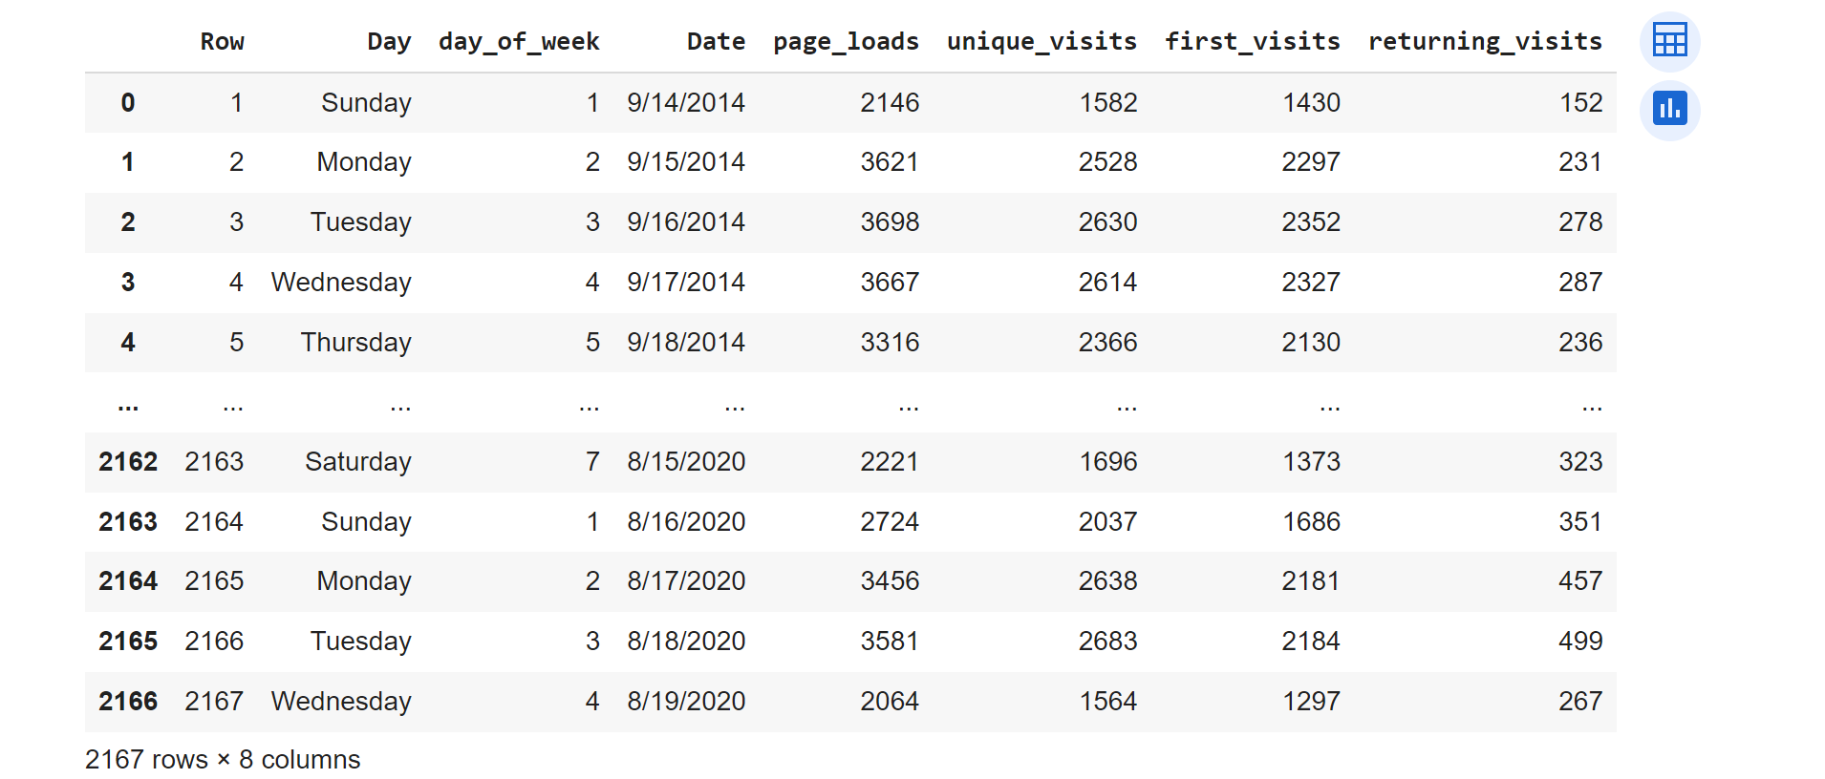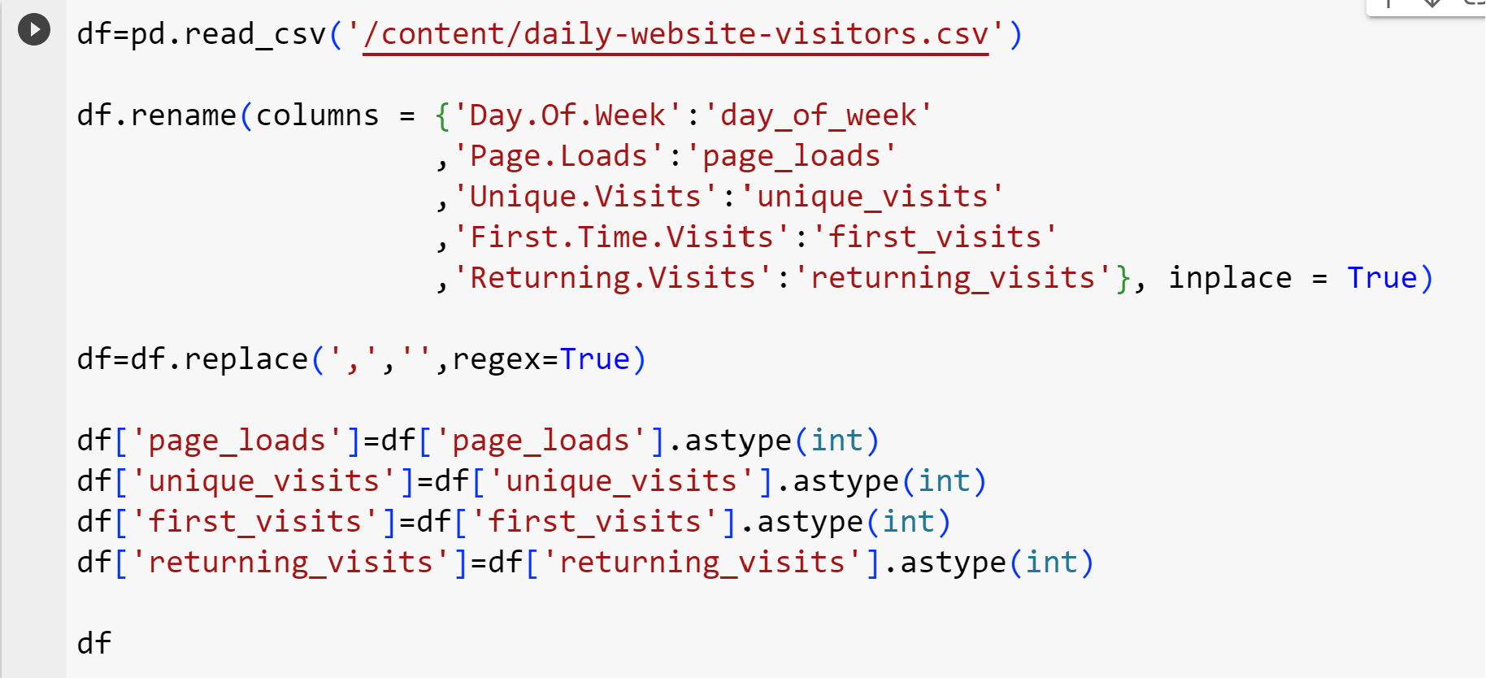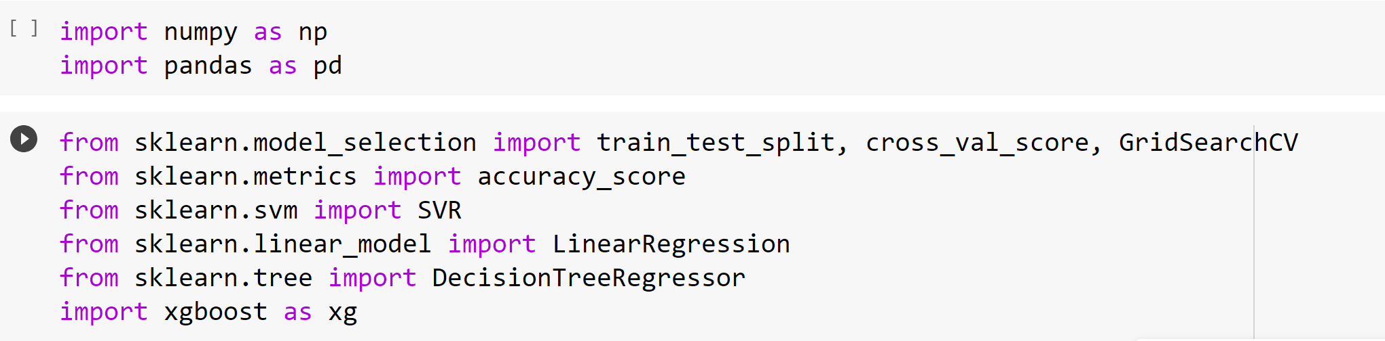**MACHINE LEARNING PREDICTION USING LINEAR REGRESSION**

